(SCHOOL NAME)

SCHOOL

LOGO

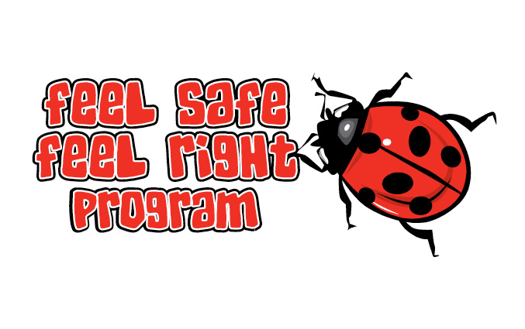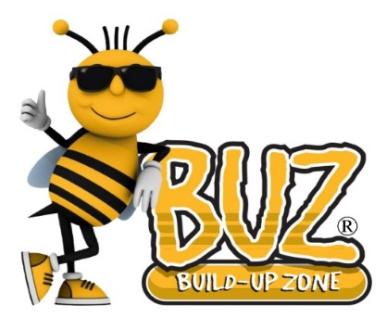

Protective Behaviours Program for Children

Dear Parents,

Students in the ( ) class(es) in room(s) ( ) at our school are about to embark upon a program to help them develop protective behaviours. The program is called “BUZ Feel Safe, Feel Right” and is presented by ( ) (Chaplain or teacher) and is one of the innovative BUZ programs from Nurture Works Foundation.

The program helps children to create a safe environment for themselves.

* It helps children become more aware of what they think or feel is 'not safe' in order to help them create a safe environment.
* It helps empower them with options when confronted with an unsafe situation or when they feel something is not safe or not right.
* Children have varying degrees of dependency on adults for their safety - the program therefore meets a child where they are at and builds on their knowledge base of unsafe situations and how to handle them.
* The program introduces two sensitively written books – “The Right Touch” by Sandy Kleven and “A Terrible Secret” by Steve Heron

The program will run for 3 hours on (Day, date and time)

The **BUZ Feel Safe Feel Right** program helps children to learn some valuable principles like:

*- “One thing 'worries' don’t like is being talked about, it makes them go away.”*

*- “Find people you trust that you can talk about the things that worry you.”*

*- “If something doesn’t feel right it is best not to do it - talk to someone you trust.”*

*- “Nothing is so terrible that you can’t tell someone about it.”*

*- “Speak up for yourself.”*

*- “It is important to say NO to someone when”;*

They are not treating you properly

They are scaring or threatening you

They touch you in a way that isn't right or you don’t like

They are teasing or hurting you or someone you love



(Teacher’s Name) (Principal’s Name)

Room ( ) Teacher School Principal



Please return the slip below only if you **DO NOT** wish for your child to participate in the program.

(SCHOOL NAME) PRIMARY SCHOOL – BUZ FEEL SAFE FEEL RIGHT PROGRAM

I DO NOT wish for …………………………………………….. (child’s name) to participate in the BUZ Feel Safe Feel Right Program in room ( ) at the school on (Day and date)

…………………………………………………………. (Parent/Guardian’s signature)